++MARJORIBANKS OF LEES

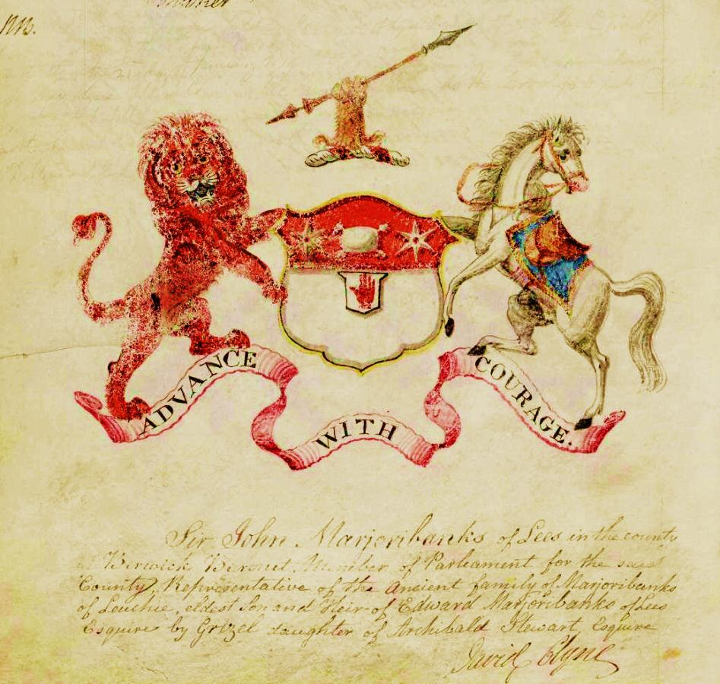
“Sir John Marjoribanks of Lees in the County of Berwick Baronet Member of Parliament for said county Representative of the ancient family of Marjoribanks of Leuchie oldest son and heir of Edward Marjoribanks of Lees Esquire by Grizel, daughter of Archibald Stewart Esquire.”
The device with accompanying quotation is derived from the Public Register of All Arms and Bearings in Scotland by kind permission of the Lord Lyon King of Arms. It was matriculated in 1818 a few years after the grant of his baronetcy, shortly after the death of his father Edward in 1815.
However, neither Sir John nor his father was by any means the first Marjoribanks to have an interest in Lees. The story is rather complex but starts with Edward’s great-uncle James, the youngest in his generation of a well-known Edinburgh family which had matriculated arms as Marjoribanks of Leuchie. Being a wealthy man, soon after his daughter Elizabeth had married James Pringle younger of Lees, James bought the estate and paid off the massive debts with which it was encumbered. In 1752 his son (also James) drew up an entail in favour of another James Pringle, reserving the reversion of the estate, should the Pringles die out – and James Pringle had no sons at the time - to Marjoribanks of Leuchie.
As it happened, this family too had suffered a remarkable lack of male heirs. Edward was James’s older son, but by 1762 his brother John had “gone to India and died.” Thus, quite unexpectedly, Edward, by now the sole remaining male heir of Leuchie, who had been peacefully pursuing a career as wine-merchant and possibly surreptitious Jacobite agent in Bordeaux, found himself inheriting Lees. He therefore brought his wife Grizel Stewart and baby son John to Lees, gave up his previous trade and settled down to life as a country gentleman. Note:- There is some dispute about the date of this inheritance, and it is possible that he did not actually take possession for some years, but there is good authority for accepting 1762 as the latest date for his inheriting the property.
Lees was an attractive, though not particularly large estate on the banks of the Tweed. An old verse cited by Charles runs:-
“While summers glow and winters freeze
Ye’ll see a braw lad at the Lees;
And Tweed’s fair mirror as it passes
Shall aye reflect its bonny lasses.”

Edward was already a Burgess and Guild Brother of Edinburgh and divided his time between Bordeaux and Hallyards, which had for several generations been the seat of his particular branch of the family. It now lies buried under the land of Edinburgh’s Turnhouse Airport.
Relatively little is known of Edward’s life at Lees; he does not seem to have been inclined to take part in the great affairs of the day, but it appears that he maintained his family’s interest in the profession of banking – his grandfather, another Edward, for instance had been town treasurer of Edinburgh. It was to his sons’ enormous benefit that he struck up a friendship with Thomas Coutts, who ran his private banking firm and made it famous throughout the island. There is a letter in the archives of Coutts’ Bank in the Strand from Edward to Coutts which bears witness both to their easy friendship and Edward’s business-like interest in the affairs of those of his sons and grandsons whose fortune depended on Coutts’s generosity.
In person Edward was stately and handsome with perfect formal manners, although as he aged his natural quick temper easily turned to rage – almost to madness. However, he was hospitable and maintained a welcoming establishment at the Lees – not as grand, perhaps, as the Home estate at the Hirsel the other side of the road, but much more homely. It was Edward, too, who was the first occupant of the attractive Family graveyard in Abbey Road, Coldstream, looking down over a green sward to the River Tweed running below.
Very much more is known of his eldest son John, the most distinguished man ever to have resided at the Lees. Indeed, all Edward’s five sons were very prominent men in their own right: in addition to John, Campbell was twice chairman of the East India Company, the most prestigious corporation in the kingdom: Stewart owned a shipping company and was M.P. for Hythe for many years: Edward became senior partner in Coutts’ Bank: and James became a judge in the East India Company’s administration of India. Perhaps none of this would have happened without Thomas Coutts’s assistance, but in fact all five of them made a great success of the positions to which he had helped them.
However, little is known of John’s education and early life. The first evidence we have is a letter from his mother to Sir Robert Murray Keith, asking for his help in preparing John, then aged 15, for a military career: ‘I am told he is a good classical scholar, but being deficient in other branches of education which are indispensable both for the soldier and the gentleman … it will be an advantage for him to spend a twelvemonth abroad to acquire … the French and German languages’. Keith, British envoy at Vienna and a family friend, obtained a place for the boy with General Douglas at Bois-le-Duc, who gave him a sound pre-military grounding. On his return further family influence obtained him a commission and he eventually rose to the rank of captain in the Coldstream Guards without having to do any serious soldiering.
When not with his regiment he appears to have lived with his parents at the Lees for most of the 1780s and it was towards the end of this period of youth and relative irresponsibility, that he fathered a son by a local girl. He acknowledged the boy and set him up in a small way of business in Coldstream as a cordwainer (shoemaker), for he was never mean or lacking in a sense of social responsibility. The descendants of this family are still settled in the area today. However, in 1787 an association began which would change his own and his brothers’ lives for ever, when his father introduced him to Thomas Coutts (1735-1822); Coutts in turn introduced him to John Stuart, Baron Cardiff, and later 4th Earl and 1st Marquess of Bute, an influential nobleman. Coutts, a man of their father’s generation rather than their own, acted as a kindly but firm uncle to John and his four brothers and set their feet confidently on the way to respectable prosperity.
In 1791, in a shrewd career move, John married Alison, daughter of William Ramsay, a wealthy banker in Edinburgh. He brought her home to his fine new house in Eccles, Berwickshire, fathering four sons and five daughters. He gave up army life and his third son Charles records of the next decade: ‘Among this hard-drinking set, most of them greatly his inferiors, were several of the best years of my father’s life thrown away’. It is true that the local gentry were hardly models of propriety, but when one considers that Charles was only born in 1794 and was removed to Edinburgh for his education while still a small boy it must be questioned how much he actually knew of his father’s affairs. In fact he appears to have disliked him, and there are more complimentary marginalia inserted in Charles’s memoir by his younger brother David. A lesson, perhaps, against trusting too far the validity of primary sources!
No doubt there were indeed some dissipated nights at Eccles House, but in fact John was doing quite well, although he was not as yet particularly wealthy. Shortly after his marriage his father-in-law had extended an invitation to become a partner in the bank of Mansfield, Ramsay, which at least secured his future. Here Charles snipes again, saying that his father had not the talents required of a banker, being inclined to an enthusiastic dash at a project rather than the steady unemotional application required in the banking business. In this case Charles was perhaps on firmer ground, for John in practice was never a very diligent banker; most of the family’s traditional stock of banking talent seems to have been absorbed by his younger brother Edward, senior partner in Coutts & Co. for many years.
His father-in-law was not on the warmest terms with him - it was not in his nature - but induced him, around the turn of the century, to return to live in Edinburgh, he bought No. 29 Charlotte Square, a fine new square at the end of George Street. Probably the need to educate his sons also influenced the move. It appears, too, that it was at this time he became a Mason, probably at Ramsay’s instigation; this was to prove an important step for the future, for it brought him into contact with the most eminent men in Scotland.
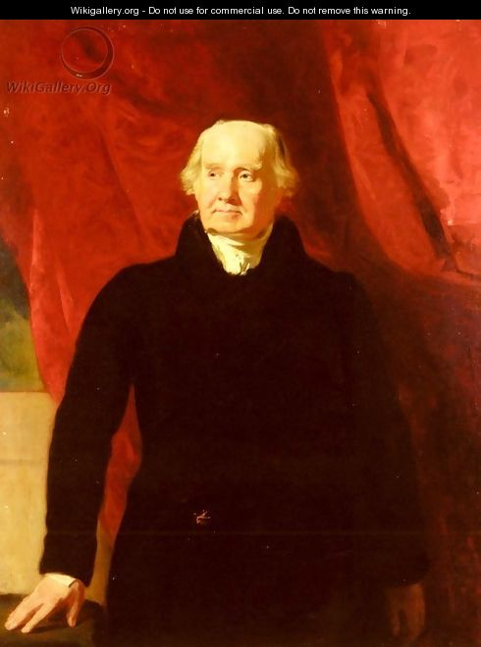
By this time he was a mature man of 40, with looks and bearing rather typical of the family - stocky and square-faced. He was said to resemble the Prince of Wales, later George IV, to whom he would in the future (1816-18) act as Assistant Grand Master of the Scottish Masons. He was, we are told, extremely intelligent although not very highly educated, but impulsive rather than methodical. Like his father, though much less extravagantly, he was liable to fits of rage; but they quickly subsided and he never struck his sons in anger. He made enemies as a result of his methods, whether in business or politics (Charles says he was fond of proceeding by ‘coup de main’) but was a loyal and faithful friend - in all, a complex but in many ways admirable man. Much of his character can be gleaned from a bundle of his letters to Thomas Coutts in the archives of Coutts & Co. and another, written to the Marquess of Bute in the collection at Mount Stuart; they show him to be a perfectly capable man of business and warmly interested both in his family - but it is noticeable that he never mentions Charles - and his own developing political career. There is, perhaps, another clue to his character in his handwriting - sprawling, eager and hasty in style, rather confirming Charles’s estimate of his general approach. However, both this and a later letter display his keen powers of observation and some interesting ideas for the development of Bute’s estate.
Bute was involved in politics at the highest level and John obviously impressed him in this capacity too, for in 1807 he was recommended to Lord Grenville as ‘a very fit man’ to consult about a Bill concerning the Bank of Scotland. By 1808 he had bought himself a vote in Buteshire, in 1811 he joined Edinburgh Town Council and in 1812 the Marquess, failing of a suitable member of his own family, ensured John’s election as Member of Parliament for Buteshire. He did this with some reluctance for, as he explained to Grenville, he was by no means sure that John would always stick to the party line. However, Bute died in 1814, freeing John of whatever obligation he may have felt: in fact more often than not he voted thereafter with Lord Liverpool’s Tory administration.
By 1812 John was therefore a distinctly eminent man, except that as a member of the mercantile rather than aristocratic class he would still, in that class-conscious age, defer to such noblemen as Lord Bute. The distinction in class meant little to the councillors of Edinburgh, who were of (or perhaps more often aspired to) John’s own social level and in 1813 proposed to him that he should become Lord Provost. Perhaps owing to the sense of deference mentioned above, before accepting he wrote both to Bute and Thomas Coutts to ask for their approval. This was granted and he duly took and held for two years the chief magistracy of Scotland’s capital.
He did not occupy it idly or merely for its prestige (let alone his allowance of £800) but revived a project which had originally been proposed some 30 years before, that of building a new jail to the east of the city, where there was more room for large-scale development: the Old Town was cramped and unhealthy, the New Town far too respectable for this particular project, while the newly completed Princes Street pointed like an arrow towards the lower slopes of Calton Hill where John intended the new jail to go. There was just one major problem: there was little room between the lower Canongate in the Old Town and the Hill for the new building and access would have to be by a road built over a rather narrow and deep valley. However, if it could be completed it would not only provide access to the jail but make possible the development of the lower slopes of Calton Hill and the broad acres beyond and also very considerably shorten the main road east, to East Lothian and eventually England via Berwick-upon-Tweed.
This was a challenge which John’s impulsive energy and forceful personality were well adapted to driving through - qualities which were officially recognised by the Council at the end of his first year of office in a vote of thanks praising his ‘zeal and ability in promotion of objects of public utility’. The same qualities were mentioned when, on his leaving office in 1815, the Council ordered a fine portrait to be painted. It is said that, in order to keep costs to the city and other institutions within reasonable limits he invested a substantial part of his personal fortune in the building project - an investment which did not in the event bring reward. Even so, the financial arrangements were complex and were not finally in place until early in 1815 - his second year as Lord Provost. The rather confused Council minute appears to show a total capital cost of some £20,000. Finally the foundation stone of the Regent Bridge over the valley was laid in his presence shortly before he left office later in that year and the great project was at last under way. He was present when the new road was opened in 1819. The bridge still stands, with an inscription recording the rank of Baronet (1st of Lees, in the County of Berwick) which had been created for him in 1815.
View from Calton Hill down Princes Street, with the new prison in the left foreground.
It had been an intensely busy two years, for not only had he been involved in a very wide range of activities in Edinburgh but he had had his responsibilities as a Member of Parliament to attend to, and his voting record shows that he did not neglect them - although an MP’s job then was much less onerous than today. He happened to be in London in June 1815 when the news of the victory of Waterloo arrived and it was he who commissioned a fast coach to take the news to Edinburgh. Nor was this his only care in that year, for it was the year of his father’s death.
Lees (together with other Scottish properties) was valued at £5045 and naturally passed to him under the terms of the entail; however his father must have had substantial investments for John was instructed to make sizeable provision, approximately £10,000, for Edward’s other children and his widow. He was in no haste to complete the formalities; his father’s will was not published until 1817. When he did turn his full attention to his inheritance he sold Eccles and rebuilt Lees as a fine modern Regency-style house; unfortunately, after the entail was broken in 1931 it became derelict and little of it now remains.
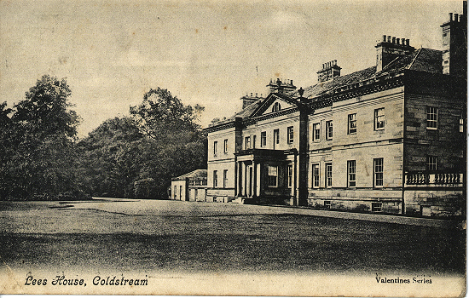
In 1818 there was another Parliamentary election and, as this time it was not Buteshire’s turn to return a member, Sir John cast about for another seat. The natural one for him was Berwickshire (the division in which Lees was) but it had a sitting member who was not inclined to retire. However, by a series of manoeuvres which were thought by some to be somewhat underhand, John persuaded him to vacate the seat and took it for himself. He was much less active politically in this period and gave up the seat at the next election. It is noticeable that, although John on the whole supported the Tory government, when his son Charles took the seat in 1833 he did so as a Liberal, as his memorial column at Coldstream proudly states.
Instead of his political activity he devoted the later phase of his life mainly to the management of his estate; he was spoken of as an able and considerate landlord. It is very possible that he was feeling the pinch financially, for it appears that he had invested a good deal of his own money in the Calton Hill project, for very little return. Charles also suggests that towards the end of his life his mind was affected by the conviction that he was ruined, although there was little real justification for such a belief.
He died in February 1833, outliving his heir Edward by a few weeks. Edward had been sent out to India to make a living as a clerk with the East India Company but, like so many young men, succumbed there to drink and debt. The title and estate therefore passed to his second son William, who had earned praise from Thomas Coutts as a sea captain trading in the China seas.
Sir John had two younger sons who both survived him. Charles was a brilliant servant of the East India Company on the Macao station, and was made a Freeman of the City of Edinburgh in his mid-thirties. He stood for his father’s old constituency in 1833, winning it as a Liberal by a narrow margin. Unfortunately his health, already undermined by his years out East and possibly by excess in his private habits, gave way completely and he was dead by the end of the year. The Liberals of Berwickshire erected a statue of him atop of a tall column, whence he commands the eastern entrance to Coldstream to this day.

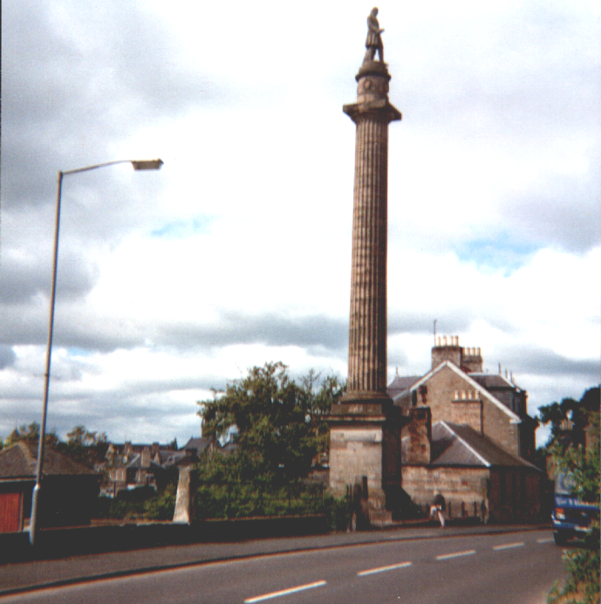
“Charlie on his Pole”
Very different was Sir John’s youngest son David. Less waspish than his brother Charles, he went into the city and became a London stockbroker, a profession to which his very precise mind was well attuned (in later life he was dismissed as a “dry old stick”). He specialized in Mexican bonds and, after reclaiming Berwickshire for the Liberals in 1859, his financial expertise was much valued by the party leadership.
He did not achieve his eminence as a Marjoribanks, however; in 1834 he changed his name to Robertson in order to secure his wife’s inheritance and the estate of Ladykirk, a few miles from Coldstream. When he was finally rewarded with a peerage in 1873, at the age of 76 he took the title of Baron Marjoribanks; but within a week he was knocked down by a horse-bus outside his club and died. His only son had predeceased him and so the title became extinct as soon as awarded; but Ladykirk remains in possession of his descendant in the female line.
Sir William took possession of Lees and of the baronetcy in 1833 but did not live long to enjoy them; perhaps worn out by his sea service, he died in 1834, leaving two young sons, John aged 4 and William aged 2, in the care of their mother Mary Stone, the daughter of a banker on the board of the East India Company (it is notable to what an extent the fortunes of these generations of this family were bound up with the Company).
Both boys were sent to Eton, but while John then went up to Christchurch, Oxford, William attended Emanuel, Cambridge. Sir John then took up his duties in Berwickshire, marrying Charlotte Trotter in 1858 (the Marjoribankses had had close relationships with the Edinburgh Trotters for centuries) and fighting the county seat, presumably as a Conservative, unsuccessfully against his uncle David in 1859. However, he continued to play a full part in the public life of the county; he was appointed a major in then local Rifle Volunteers in 1860 and Lieutenant Colonel in 1867. He was also a Magistrate and Deputy Lieutenant of Berwickshire and Magistrate for Northumberland.
Nor did he neglect his home town of Coldstream; a handsome memorial stands in the High Street by the Church, commemorating his good service to the town in ensuring a supply of clean water. Unfortunately he died in 1884 at the age of 54; his marriage had proved childless, so Lees and the baronetcy passed to his brother William, who had been living quietly at Leamington with his wife Mary Duppa.
As it happened, William too died childless within less than four years and so the baronetcy became extinct; under the terms of the entail Lees passed to a cousin, George Marjoribanks, a partner and later (as Sir George) Chairman of Coutts Bank. Naturally enough, Sir George, though proud of the traditional family seat of Lees, regarded it mainly as a holiday home. By the time he died in 1931 the law had changed and the entail was broken; he left Lees to his daughter Monica, who promptly sold it.
So the story of Marjoribanks of Lees comes to an end, though those of us who descend from Edward, the first Sir John’s younger brother, consider ourselves the 21st Century representatives of the Family. Lees itself went through a rather ignominious period after it passed out of our hands; the gentleman who bought the estate valued it only for its fishing (and a salmon fishing beat on the Tweed is indeed a valuable asset) and the house sank into dereliction. Its destruction was almost completed by the Coldstream fire brigade, who burned a good deal of it as part of an exercise. Fortunately it has now been acquired by a scion of the Douglas-Home family from the Hirsel; he has rebuilt what could be rescued as a fine family home and has been restoring the grounds. With the estate in such good hands the remaining Marjoribankses of Lees may be well satisfied.
Roger James Marjoribanks
Guildford, October 2012.

For the details in this section I am indebted to “The History of the Berwickshire Naturalists’ Club” (1879) , which contains an essay by James Hardy on the Estate of Lees.
As recorded by Edward’s grandson Charles.
According to his grandson Charles Marjoribanks, MS in library of the Signet, Edinburgh.
Thorne, House of Commons, p. 546. The passage suggests that John had received a typically narrow Scottish rural school education.
Charles Marjoribanks, ‘Memoir’.
Portrait of Sir John Marjoribanks by Andrew Geddes.
See also A Series of Original Portraits ... by the late John Kay, 2 vols (Edinburgh 1838), II, pp. 294-296.
Charles Marjoribanks, ‘Memoir’.
John Marjoribanks to Thomas Coutts, 29 August, 1808, letter in archives of Coutts Bank, London.
Grenville was Prime Minister at the time, but throughout John’s period in Parliament leader of the Whig Opposition.
At this time he retired from the bank, of which he was by now the most important remaining partner.
Edinburgh City Archives (ECA), Town Council Minutes (TCM), 14 September 1814.
ECA, TCM, 2 March 1815.
Contemporary engraving.
Probate of the will is archived at Coutts Bank, London.
She was Marianne Haggerston, granddaughter and eventual heir of William Robertson of Ladykirk.
Had the entail not been broken Lees would have passed to my father Stewart, although, since he had just started a preparatory school in North London it is not clear what he could have done with it.

